Experiment 1
Develop a web page with suitable HTML elements to demonstrate Bootstrap framework classes for headings.

HTML Code : Document name is heading.html

<!DOCTYPE html>
<html lang="en">
<head>
<meta charset="UTF-8">
<meta name="viewport" content="width=device-width, initial-scale=1.0">
<title>Bootstrap Headings Demonstration</title>
<!-- Bootstrap CSS CDN -->
<link href="https://cdn.jsdelivr.net/npm/bootstrap@5.3.3/dist/css/bootstrap.min.css" rel="stylesheet" integrity="sha384-QWTKZyjpPEjISv5WaRU9OFeRpok6YctnYmDr5pNlyT2bRjXh0JMhjY6hW+ALEwIH" crossorigin="anonymous">
</head>
<body>
<div class="container my-5">
<!-- Main Title -->
<div class="text-center mb-5">
<h1 class="display-4 fw-bold text-primary">Bootstrap Headings Framework Demo</h1>
<p class="lead text-secondary">This page demonstrates Bootstrap's heading classes using standard &lt;h1&gt; to &lt;h6&gt; elements, as well as applying .h1 to .h6 classes to non-heading elements. It also showcases display heading classes (.display-1 to .display-6) for prominent, larger headings.</p>
</div>

<!-- Section 1: Standard Headings -->
<section class="mb-5">
<h2 class="border-bottom pb-2 mb-4 text-success">1. Standard Headings (Using &lt;h1&gt; to &lt;h6&gt; Tags)</h2>
<p class="text-muted">Bootstrap styles these semantic HTML elements with decreasing font sizes and weights for hierarchy.</p>

<h1 class="text-primary">h1. Bootstrap Heading (Largest, 2.5rem, bold)</h1>
<h2 class="text-secondary">h2. Bootstrap Heading (2rem, bold)</h2>
<h3 class="text-success">h3. Bootstrap Heading (1.75rem, bold)</h3>
<h4 class="text-danger">h4. Bootstrap Heading (1.5rem, bold)</h4>
<h5 class="text-warning">h5. Bootstrap Heading (1.25rem, bold)</h5>
<h6 class="text-info">h6. Bootstrap Heading (1rem, bold, Smallest)</h6>
</section>

<!-- Section 2: Applying Heading Classes to Non-Heading Elements -->
<section class="mb-5">
<h2 class="border-bottom pb-2 mb-4 text-info">2. Applying .h1 to .h6 Classes to Other Elements</h2>
<p class="text-muted">These utility classes can be applied to any element (e.g., &lt;p&gt;, &lt;div&gt;) to mimic heading styles without semantic meaning.</p>

<p class="h1 text-primary">p with .h1 class (Styled like h1, 2.5rem, bold)</p>
<p class="h2 text-secondary">p with .h2 class (Styled like h2, 2rem, bold)</p>
<p class="h3 text-success">p with .h3 class (Styled like h3, 1.75rem, bold)</p>
<p class="h4 text-danger">p with .h4 class (Styled like h4, 1.5rem, bold)</p>
<p class="h5 text-warning">p with .h5 class (Styled like h5, 1.25rem, bold)</p>
<p class="h6 text-info">p with .h6 class (Styled like h6, 1rem, bold)</p>
</section>

<!-- Section 3: Display Headings -->
<section class="mb-5">
<h2 class="border-bottom pb-2 mb-4 text-warning">3. Display Headings (.display-1 to .display-6 Classes)</h2>
<p class="text-muted">These classes create prominent headings with larger font sizes, lighter weights, and wider letter-spacing. Ideal for hero sections or titles. Applied to any element.</p>

<h1 class="display-1 text-primary">Display 1 (Very Large, 6rem, light weight)</h1>
<h1 class="display-2 text-secondary">Display 2 (5.5rem, light weight)</h1>
<h1 class="display-3 text-success">Display 3 (4.5rem, light weight)</h1>
<h1 class="display-4 text-danger">Display 4 (3.5rem, light weight)</h1>
<h1 class="display-5 text-warning">Display 5 (2.5rem, light weight)</h1>
<h1 class="display-6 text-info">Display 6 (2rem, light weight)</h1>
</section>

<!-- Section 4: Responsive Considerations -->
<section class="mb-5">
<h2 class="border-bottom pb-2 mb-4 text-danger">4. Responsive Behavior</h2>
<p class="text-muted">Headings are responsive by default in Bootstrap. On smaller screens, font sizes scale down. Test by resizing the browser window.</p>
<div class="row">
<div class="col-md-6">
<h1 class="text-primary">Responsive h1 (Scales on mobile)</h1>
</div>
<div class="col-md-6">
<p class="display-4 text-secondary">Responsive Display 4 (Even larger on desktop) </p>
</div>
</div>
</section>

<!-- Section 5: Headings with Secondary Text -->
<section class="mb-5">
<h2 class="border-bottom pb-2 mb-4 text-dark">5. Headings with Secondary Text</h2>
<p class="text-muted">Bootstrap allows adding secondary (smaller, lighter) text to headings using the &lt;small&gt; element or the .text-muted class. This is useful for subtitles or additional context.</p>

<h1 class="text-primary">Primary Heading <small class="text-muted">Secondary text (using &lt;small&gt;)</small></h1>
<h2 class="text-secondary">Primary Heading <small class="text-muted">Secondary text (using &lt;small&gt;)</small></h2>
<h3 class="text-success">Primary Heading <small class="text-muted">Secondary text (using &lt;small&gt;)</small></h3>
<h4 class="text-danger">Primary Heading <small class="text-muted">Secondary text (using &lt;small&gt;)</small></h4>
<h5 class="text-warning">Primary Heading <small class="text-muted">Secondary text (using &lt;small&gt;)</small></h5>
<h6 class="text-info">Primary Heading <small class="text-muted">Secondary text (using &lt;small&gt;)</small></h6>

<hr class="my-4">

<h1 class="text-primary">Primary Heading <span class="text-muted">Secondary text (using .text-muted)</span></h1>
<h2 class="text-secondary">Primary Heading <span class="text-muted">Secondary text (using .text-muted)</span></h2>
</section>

<!-- Footer Note -->
<footer class="text-center text-muted mt-5 pt-4 border-top">
<p>This demo uses Bootstrap 5.3.3. View source for full HTML structure.</p>
</footer>
</div>

<!-- Bootstrap JS (Optional for full framework, but not required for headings) -->
<script src="https://cdn.jsdelivr.net/npm/bootstrap@5.3.3/dist/js/bootstrap.bundle.min.js" integrity="sha384-YvpcrYf0tY3lHB60NNkmXc5s9fDVZLESaAA55NDzOxhy9GkcIdslK1eN7N6jIeHz" crossorigin="anonymous"></script>
</body>
</html>
Output
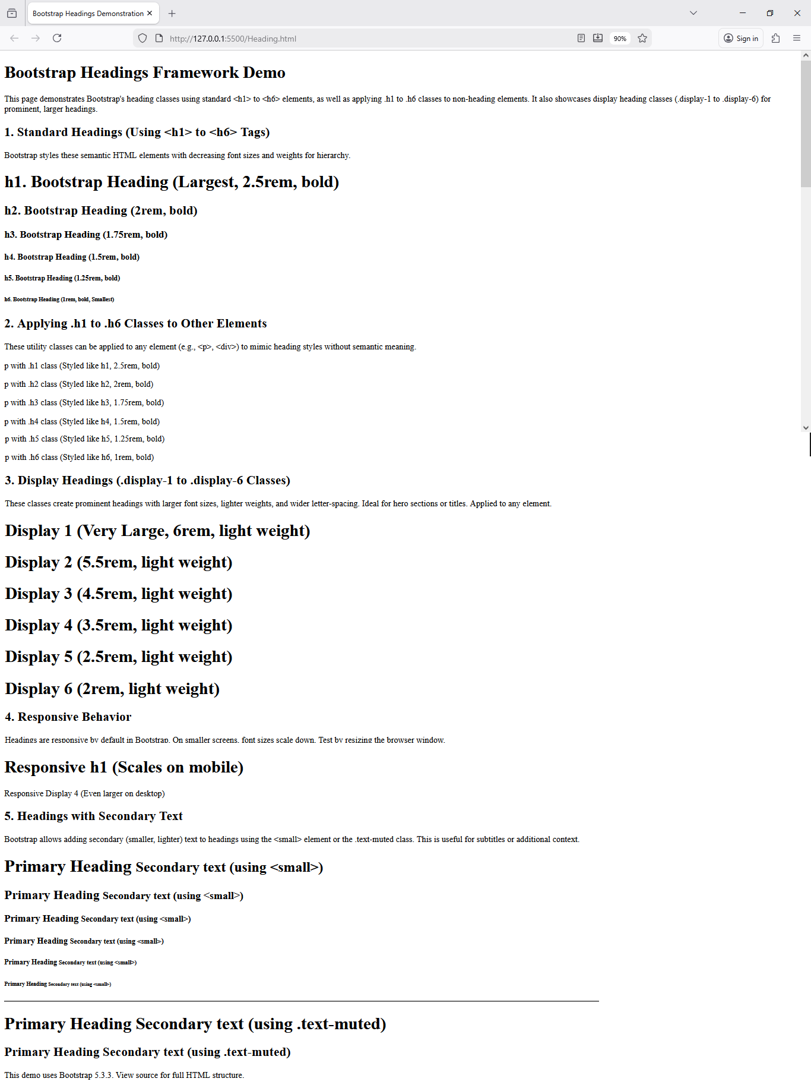
Experiment 2
Develop a Web page with suitable HTML elements to demonstrate Bootstrap framework classes for text and fonts.

Code Example

<!DOCTYPE html>
<html lang="en">
<head>
<meta charset="UTF-8">
<meta name="viewport" content="width=device-width, initial-scale=1.0">
<title>Bootstrap Text and Fonts Demo</title>
<!-- Bootstrap CSS CDN -->
<link href="https://cdn.jsdelivr.net/npm/bootstrap@5.3.2/dist/css/bootstrap.min.css" rel="stylesheet">
</head>
<body>
<div class="container mt-5">
<h1 class="text-center text-primary mb-4">Bootstrap Text and Fonts Demonstration</h1>

<!-- Text Alignment -->
<section class="mb-5">
<h2 class="text-decoration-underline">1. Text Alignment</h2>
<p class="text-start">This text is aligned to the left (start).</p>
<p class="text-center">This text is centered.</p>
<p class="text-end">This text is aligned to the right (end).</p>
</section>

<!-- Text Transformation -->
<section class="mb-5">
<h2 class="text-decoration-underline">2. Text Transformation</h2>
<p class="text-lowercase">THIS TEXT WILL BE LOWERCASE</p>
<p class="text-uppercase">this text will be uppercase</p>
<p class="text-capitalize">capitalize first letter of each word</p>
</section>

<!-- Font Weight -->
<section class="mb-5">
<h2 class="text-decoration-underline">3. Font Weight</h2>
<p class="fw-bold">This is bold text</p>
<p class="fw-bolder">This is bolder text</p>
<p class="fw-semibold">This is semibold text</p>
<p class="fw-normal">This is normal weight text</p>
<p class="fw-light">This is light text</p>
<p class="fw-lighter">This is lighter text</p>
</section>

<!-- Font Style -->
<section class="mb-5">
<h2 class="text-decoration-underline">4. Font Style</h2>
<p class="fst-italic">This text is in italics</p>
<p class="fst-normal">This text is in normal style</p>
</section>

<!-- Text Decoration -->
<section class="mb-5">
<h2 class="text-decoration-underline">5. Text Decoration</h2>
<p class="text-decoration-underline">This text has an underline</p>
<p class="text-decoration-line-through">This text has a line through it</p>
<p class="text-decoration-none">This text has no decoration</p>
</section>

<!-- Display Headings -->
<section class="mb-5">
<h2 class="text-decoration-underline">6. Display Headings</h2>
<h1 class="display-1">Display 1</h1>
<h1 class="display-2">Display 2</h1>
<h1 class="display-3">Display 3</h1>
<h1 class="display-4">Display 4</h1>
<h1 class="display-5">Display 5</h1>
<h1 class="display-6">Display 6</h1>
</section>

<!-- Special Text Elements -->
<section class="mb-5">
<h2 class="text-decoration-underline">7. Special Text Elements</h2>
<p class="lead">This is a lead paragraph. It stands out from regular paragraphs.</p>
<p>This is a regular paragraph with <mark>highlighted text</mark>.</p>
<p><small>This is small text</small></p>
<p><strong>Bold text using strong tag</strong></p>
<p><em>Italic text using em tag</em></p>
<p>H<sub>2</sub>O - Subscript example</p>
<p>X<sup>2</sup> - Superscript example</p>
</section>

<!-- Monospace Font -->
<section class="mb-5">
<h2 class="text-decoration-underline">8. Monospace Font</h2>
<p class="font-monospace">This text uses monospace font family</p>
</section>

<!-- Text Wrapping and Breaking -->
<section class="mb-5">
<h2 class="text-decoration-underline">9. Text Wrapping</h2>
<div class="badge bg-primary text-wrap" style="width: 6rem;">
This text should wrap
</div>
<div class="text-nowrap bg-light border mt-2" style="width: 8rem;">
This text should not wrap and will overflow
</div>
</section>
<!-- Text Reset -->
<section class="mb-5">
<h2 class="text-decoration-underline">10. Text Reset</h2>
<p class="text-muted">
Muted text with a <a href="#" class="text-reset">reset link</a>.
</p>
</section>
</div>
<!-- Bootstrap JS Bundle -->
<script src="https://cdn.jsdelivr.net/npm/bootstrap@5.3.2/dist/js/bootstrap.bundle.min.js"></script>
</body> </html>
Output
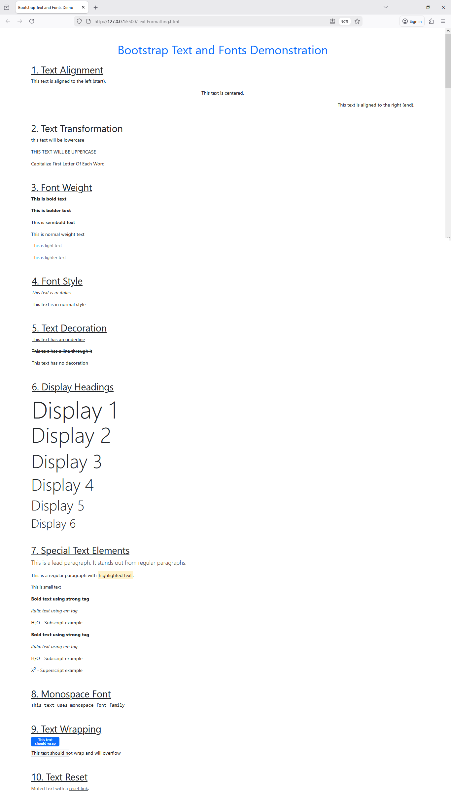
Experiment 3
Develop web pages with suitable HTML elements to demonstrate Bootstrap framework classes for Lists, colors, and bootstrap buttons

Code Example
html
<!DOCTYPE html>
<html lang="en">
<head>
<meta charset="UTF-8">
<meta name="viewport" content="width=device-width, initial-scale=1.0">
<title>Bootstrap Lists, Colors, and Buttons Demo</title>
<!-- Bootstrap CSS CDN -->
<link href="https://cdn.jsdelivr.net/npm/bootstrap@5.3.2/dist/css/bootstrap.min.css" rel="stylesheet">
</head>
<body>
<div class="container mt-5">
<h1 class="text-center text-primary mb-5">Bootstrap Lists, Colors, and Buttons</h1>

<!-- LISTS SECTION -->
<div class="row mb-5">
<div class="col-12">
<h2 class="text-decoration-underline mb-4">A. Lists Demonstration</h2>
</div>

<!-- Unstyled List -->
<div class="col-md-4 mb-4">
<h4>1. Unstyled List</h4>
<ul class="list-unstyled">
<li>HTML</li>
<li>CSS</li>
<li>JavaScript</li>
<li>Bootstrap</li>
</ul>
</div>

<!-- Inline List -->
<div class="col-md-4 mb-4">
<h4>2. Inline List</h4>
<ul class="list-inline">
<li class="list-inline-item">Home</li>
<li class="list-inline-item">About</li>
<li class="list-inline-item">Services</li>
<li class="list-inline-item">Contact</li>
</ul>
</div>

<!-- Description List -->
<div class="col-md-4 mb-4">
<h4>3. Description List</h4>
<dl class="row">
<dt class="col-sm-4">HTML</dt>
<dd class="col-sm-8">HyperText Markup Language</dd>
<dt class="col-sm-4">CSS</dt>
<dd class="col-sm-8">Cascading Style Sheets</dd>
</dl>
</div>

<!-- List Group -->
<div class="col-md-6 mb-4">
<h4>4. List Group</h4>
<ul class="list-group">
<li class="list-group-item">Basic list item</li>
<li class="list-group-item active">Active list item</li>
<li class="list-group-item">Another list item</li>
<li class="list-group-item disabled">Disabled list item</li>
</ul>
</div>

<!-- List Group with Colors -->
<div class="col-md-6 mb-4">
<h4>5. Colored List Group</h4>
<ul class="list-group">
<li class="list-group-item list-group-item-primary">Primary item</li>
<li class="list-group-item list-group-item-success">Success item</li>
<li class="list-group-item list-group-item-warning">Warning item</li>
<li class="list-group-item list-group-item-danger">Danger item</li>
<li class="list-group-item list-group-item-info">Info item</li>
</ul>
</div>
</div>

<hr class="my-5">

<!-- COLORS SECTION -->
<div class="row mb-5">
<div class="col-12">
<h2 class="text-decoration-underline mb-4">B. Colors Demonstration</h2>
</div>

<!-- Text Colors -->
<div class="col-md-6 mb-4">
<h4>1. Text Colors</h4>
<p class="text-primary">Primary text color</p>
<p class="text-secondary">Secondary text color</p>
<p class="text-success">Success text color</p>
<p class="text-danger">Danger text color</p>
<p class="text-warning">Warning text color</p>
<p class="text-info">Info text color</p>
<p class="text-light bg-dark">Light text color</p>
<p class="text-dark">Dark text color</p>
<p class="text-muted">Muted text color</p>
</div>

<!-- Background Colors -->
<div class="col-md-6 mb-4">
<h4>2. Background Colors</h4>
<div class="bg-primary text-white p-2 mb-2">Primary background</div>
<div class="bg-secondary text-white p-2 mb-2">Secondary background</div>
<div class="bg-success text-white p-2 mb-2">Success background</div>
<div class="bg-danger text-white p-2 mb-2">Danger background</div>
<div class="bg-warning text-dark p-2 mb-2">Warning background</div>
<div class="bg-info text-white p-2 mb-2">Info background</div>
<div class="bg-light text-dark p-2 mb-2">Light background</div>
<div class="bg-dark text-white p-2 mb-2">Dark background</div>
</div>

<!-- Alerts -->
<div class="col-12 mb-4">
<h4>3. Alert Components</h4>
<div class="alert alert-primary" role="alert">
A simple primary alert—check it out!
</div>
<div class="alert alert-success" role="alert">
A simple success alert—check it out!
</div>
<div class="alert alert-warning" role="alert">
A simple warning alert—check it out!
</div>
<div class="alert alert-danger" role="alert">
A simple danger alert—check it out!
</div>
</div>

<!-- Badges -->
<div class="col-12 mb-4">
<h4>4. Badges with Colors</h4>
<span class="badge bg-primary me-2">Primary</span>
<span class="badge bg-secondary me-2">Secondary</span>
<span class="badge bg-success me-2">Success</span>
<span class="badge bg-danger me-2">Danger</span>
<span class="badge bg-warning text-dark me-2">Warning</span>
<span class="badge bg-info me-2">Info</span>
<span class="badge bg-light text-dark me-2">Light</span>
<span class="badge bg-dark">Dark</span>
</div>
</div>

<hr class="my-5">

<!-- BUTTONS SECTION -->
<div class="row mb-5">
<div class="col-12">
<h2 class="text-decoration-underline mb-4">C. Buttons Demonstration</h2>
</div>

<!-- Basic Buttons -->
<div class="col-12 mb-4">
<h4>1. Basic Button Colors</h4>
<button type="button" class="btn btn-primary me-2 mb-2">Primary</button>
<button type="button" class="btn btn-secondary me-2 mb-2">Secondary</button>
<button type="button" class="btn btn-success me-2 mb-2">Success</button>
<button type="button" class="btn btn-danger me-2 mb-2">Danger</button>
<button type="button" class="btn btn-warning me-2 mb-2">Warning</button>
<button type="button" class="btn btn-info me-2 mb-2">Info</button>
<button type="button" class="btn btn-light me-2 mb-2">Light</button>
<button type="button" class="btn btn-dark me-2 mb-2">Dark</button>
<button type="button" class="btn btn-link me-2 mb-2">Link</button>
</div>

<!-- Outline Buttons -->
<div class="col-12 mb-4">
<h4>2. Outline Buttons</h4>
<button type="button" class="btn btn-outline-primary me-2 mb-2">Primary</button>
<button type="button" class="btn btn-outline-secondary me-2 mb-2">Secondary</button>
<button type="button" class="btn btn-outline-success me-2 mb-2">Success</button>
<button type="button" class="btn btn-outline-danger me-2 mb-2">Danger</button>
<button type="button" class="btn btn-outline-warning me-2 mb-2">Warning</button>
<button type="button" class="btn btn-outline-info me-2 mb-2">Info</button>
<button type="button" class="btn btn-outline-dark me-2 mb-2">Dark</button>
</div>

<!-- Button Sizes -->
<div class="col-12 mb-4">
<h4>3. Button Sizes</h4>
<button type="button" class="btn btn-primary btn-lg me-2 mb-2">Large Button</button>
<button type="button" class="btn btn-primary me-2 mb-2">Default Button</button>
<button type="button" class="btn btn-primary btn-sm me-2 mb-2">Small Button</button>
</div>

<!-- Button States -->
<div class="col-12 mb-4">
<h4>4. Button States</h4>
<button type="button" class="btn btn-primary me-2 mb-2">Normal Button</button>
<button type="button" class="btn btn-primary active me-2 mb-2">Active Button</button>
<button type="button" class="btn btn-primary me-2 mb-2" disabled>Disabled Button</button>
</div>

<!-- Block Buttons -->
<div class="col-12 mb-4">
<h4>5. Block Level Buttons</h4>
<div class="d-grid gap-2">
<button class="btn btn-primary" type="button">Block Level Button</button>
<button class="btn btn-secondary" type="button">Block Level Button</button>
</div>
</div>

<!-- Button Groups -->
<div class="col-12 mb-4">
<h4>6. Button Groups</h4>
<div class="btn-group me-3 mb-2" role="group">
<button type="button" class="btn btn-primary">Left</button>
<button type="button" class="btn btn-primary">Middle</button>
<button type="button" class="btn btn-primary">Right</button>
</div>
<div class="btn-group mb-2" role="group">
<button type="button" class="btn btn-outline-primary">One</button>
<button type="button" class="btn btn-outline-primary">Two</button>
<button type="button" class="btn btn-outline-primary">Three</button>
</div>
</div>

<!-- Button with Icons -->
<div class="col-12 mb-4">
<h4>7. Buttons with Text and Icons</h4>
<button type="button" class="btn btn-success me-2 mb-2">
✓ Save
</button>
<button type="button" class="btn btn-danger me-2 mb-2">
✕ Delete
</button>
<button type="button" class="btn btn-info me-2 mb-2">
⟳ Refresh
</button>
<button type="button" class="btn btn-warning me-2 mb-2">
⚙ Settings
</button>
</div>
</div>
</div>

<!-- Bootstrap JS Bundle -->
<script src="https://cdn.jsdelivr.net/npm/bootstrap@5.3.2/dist/js/bootstrap.bundle.min.js"></script>
</body>
</html>

Output
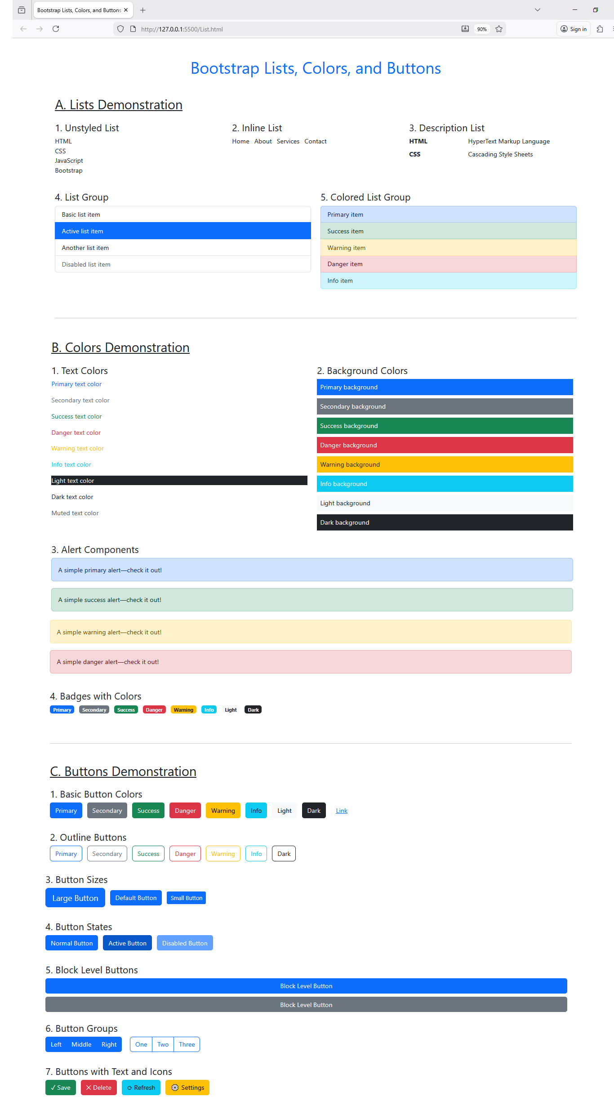
Experiment 4
Develop a Web page with suitable HTML elements to demonstrate Bootstrap Framework classes for Borders, Margins, and Paddings
Code Example
html
<!DOCTYPE html>
<html lang="en">
<head>
<meta charset="UTF-8">
<meta name="viewport" content="width=device-width, initial-scale=1.0">
<title>Bootstrap Borders, Margins & Paddings Demo</title>
<link href="https://cdn.jsdelivr.net/npm/bootstrap@5.3.2/dist/css/bootstrap.min.css" rel="stylesheet">
<style>
.demo-box {
background-color: #e9ecef;
min-height: 50px;
display: flex;
align-items: center;
justify-content: center;
}
.section-title {
background-color: #007bff;
color: white;
padding: 10px;
margin: 20px 0;
}
</style>
</head>
<body>
<div class="container my-5">
<h1 class="text-center mb-5">Bootstrap Utilities Demo</h1>

<!-- BORDERS SECTION -->
<div class="section-title">1. BORDERS</div>

<h3 class="mb-3">Basic Borders</h3>
<div class="row mb-4">
<div class="col-md-3">
<div class="demo-box border">
.border
</div>
</div>
<div class="col-md-3">
<div class="demo-box border-top">
.border-top
</div>
</div>
<div class="col-md-3">
<div class="demo-box border-end">
.border-end
</div>
</div>
<div class="col-md-3">
<div class="demo-box border-bottom">
.border-bottom
</div>
</div>
</div>

<h3 class="mb-3">Border Colors</h3>
<div class="row mb-4">
<div class="col-md-2">
<div class="demo-box border border-primary">
.border-primary
</div>
</div>
<div class="col-md-2">
<div class="demo-box border border-success">
.border-success
</div>
</div>
<div class="col-md-2">
<div class="demo-box border border-danger">
.border-danger
</div>
</div>
<div class="col-md-2">
<div class="demo-box border border-warning">
.border-warning
</div>
</div>
<div class="col-md-2">
<div class="demo-box border border-info">
.border-info
</div>
</div>
<div class="col-md-2">
<div class="demo-box border border-dark">
.border-dark
</div>
</div>
</div>

<h3 class="mb-3">Border Radius</h3>
<div class="row mb-4">
<div class="col-md-3">
<div class="demo-box border rounded">
.rounded
</div>
</div>
<div class="col-md-3">
<div class="demo-box border rounded-circle" style="width: 100px; height: 100px;">
.rounded-circle
</div>
</div>
<div class="col-md-3">
<div class="demo-box border rounded-pill">
.rounded-pill
</div>
</div>
<div class="col-md-3">
<div class="demo-box border rounded-3">
.rounded-3
</div>
</div>
</div>

<!-- MARGINS SECTION -->
<div class="section-title">2. MARGINS</div>

<h3 class="mb-3">Margin Examples</h3>
<div class="border p-3 mb-4">
<div class="demo-box border m-0 mb-2">m-0 (no margin)</div>
<div class="demo-box border m-3 mb-2">m-3 (margin all sides)</div>
<div class="demo-box border mt-5 mb-2">mt-5 (top margin)</div>
<div class="demo-box border mx-auto mb-2" style="width: 50%;">mx-auto (center horizontally)</div>
<div class="demo-box border ms-5 mb-2">ms-5 (margin start/left)</div>
</div>

<h3 class="mb-3">Margin Sizes (0-5)</h3>
<div class="border p-3 mb-4" style="background-color: #f8f9fa;">
<div class="demo-box border bg-white m-1">m-1</div>
<div class="demo-box border bg-white m-2">m-2</div>
<div class="demo-box border bg-white m-3">m-3</div>
<div class="demo-box border bg-white m-4">m-4</div>
<div class="demo-box border bg-white m-5">m-5</div>
</div>

<!-- PADDINGS SECTION -->
<div class="section-title">3. PADDINGS</div>

<h3 class="mb-3">Padding Examples</h3>
<div class="row mb-4">
<div class="col-md-4">
<div class="demo-box border p-0">
p-0 (no padding)
</div>
</div>
<div class="col-md-4">
<div class="demo-box border p-3">
p-3 (padding all sides)
</div>
</div>
<div class="col-md-4">
<div class="demo-box border p-5">
p-5 (large padding)
</div>
</div>
</div>

<h3 class="mb-3">Directional Padding</h3>
<div class="row mb-4">
<div class="col-md-3">
<div class="demo-box border pt-5">
pt-5 (top)
</div>
</div>
<div class="col-md-3">
<div class="demo-box border pb-5">
pb-5 (bottom)
</div>
</div>
<div class="col-md-3">
<div class="demo-box border ps-5">
ps-5 (start/left)
</div>
</div>
<div class="col-md-3">
<div class="demo-box border pe-5">
pe-5 (end/right)
</div>
</div>
</div>

<!-- COMBINED EXAMPLE -->
<div class="section-title">4. COMBINED UTILITIES</div>

<div class="row">
<div class="col-md-6">
<div class="border border-primary border-3 rounded p-4 m-3 bg-light">
<h4>Card with Combined Utilities</h4>
<p class="mb-0">This box uses: border, border-primary, border-3, rounded, p-4, m-3, bg-light</p>
</div>
</div>
<div class="col-md-6">
<div class="border border-success border-2 rounded-pill p-4 m-3">
<h4>Another Card</h4>
<p class="mb-0">This box uses: border, border-success, border-2, rounded-pill, p-4, m-3</p>
</div>
</div>
</div>
</div>

<script src="https://cdn.jsdelivr.net/npm/bootstrap@5.3.2/dist/js/bootstrap.bundle.min.js"></script>
</body>
</html>

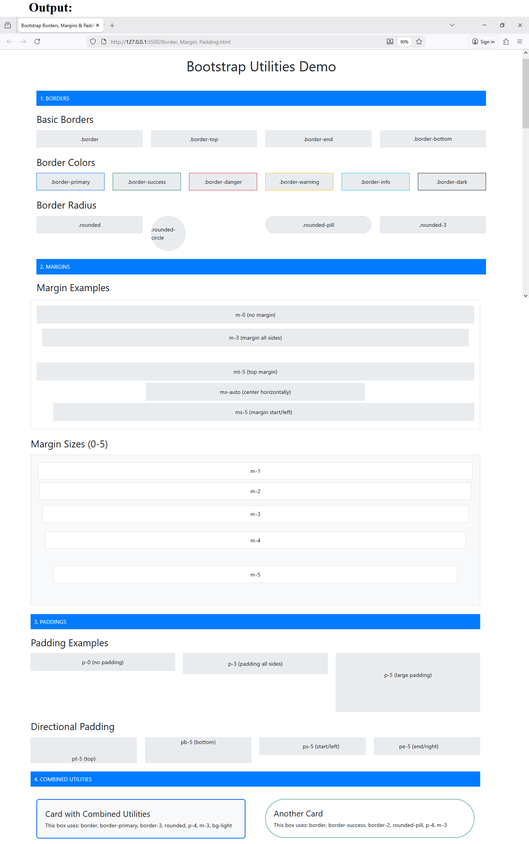
Experiment 5
Develop web pages with suitable HTML elements to demonstrate Bootstrap framework classes for Containers

Code Example

<!DOCTYPE html>
<html lang="en">
<head>
<meta charset="UTF-8">
<meta name="viewport" content="width=device-width, initial-scale=1.0">
<title>Bootstrap Containers Demo</title>
<link href="https://cdn.jsdelivr.net/npm/bootstrap@5.3.2/dist/css/bootstrap.min.css" rel="stylesheet">
<style>
body {
background-color: #f5f5f5;
}
.container-demo {
background-color: #007bff;
color: white;
padding: 30px;
margin-bottom: 20px;
border-radius: 5px;
}
.inner-content {
background-color: rgba(255, 255, 255, 0.2);
padding: 20px;
border-radius: 3px;
}
.info-box {
background-color: #fff;
color: #333;
padding: 15px;
margin-top: 10px;
border-left: 4px solid #007bff;
}
.header-section {
background: linear-gradient(135deg, #667eea 0%, #764ba2 100%);
color: white;
padding: 40px 0;
margin-bottom: 30px;
}
.comparison-table {
background-color: white;
border-radius: 5px;
overflow: hidden;
}
</style>
</head>
<body>
<div class="header-section">
<div class="container">
<h1 class="text-center">Bootstrap Containers Demonstration</h1>
<p class="text-center mb-0">Resize your browser to see responsive behavior</p>
</div>
</div>

<!-- CONTAINER -->
<div class="container container-demo">
<h2>.container (Responsive Fixed-Width)</h2>
<div class="inner-content">
<p><strong>Current container behavior:</strong></p>
<ul>
<li>Max-width changes at each breakpoint</li>
<li>Centered with auto margins</li>
<li>Responsive padding on sides</li>
</ul>
</div>
<div class="info-box">
<strong>Width at breakpoints:</strong> sm: 540px | md: 720px | lg: 960px | xl: 1140px | xxl: 1320px
</div>
</div>

<!-- CONTAINER FLUID -->
<div class="container-fluid container-demo" style="background-color: #28a745;">
<h2>.container-fluid (Full Width)</h2>
<div class="inner-content">
<p><strong>Current container behavior:</strong></p>
<ul>
<li>Always 100% width of viewport</li>
<li>Expands to fill entire screen width</li>
<li>Ideal for full-width designs</li>
</ul>
</div>
<div class="info-box" style="border-left-color: #28a745;">
<strong>Use cases:</strong> Hero sections, full-width backgrounds, fluid layouts
</div>
</div>

<!-- CONTAINER SM -->
<div class="container-sm container-demo" style="background-color: #fd7e14;">
<h2>.container-sm</h2>
<div class="inner-content">
<p><strong>100% width until small breakpoint (≥576px)</strong></p>
<p>Then behaves like regular .container</p>
</div>
</div>

<!-- CONTAINER MD -->
<div class="container-md container-demo" style="background-color: #e83e8c;">
<h2>.container-md</h2>
<div class="inner-content">
<p><strong>100% width until medium breakpoint (≥768px)</strong></p>
<p>Then behaves like regular .container</p>
</div>
</div>

<!-- CONTAINER LG -->
<div class="container-lg container-demo" style="background-color: #6f42c1;">
<h2>.container-lg</h2>
<div class="inner-content">
<p><strong>100% width until large breakpoint (≥992px)</strong></p>
<p>Then behaves like regular .container</p>
</div>
</div>

<!-- CONTAINER XL -->
<div class="container-xl container-demo" style="background-color: #20c997;">
<h2>.container-xl</h2>
<div class="inner-content">
<p><strong>100% width until extra-large breakpoint (≥1200px)</strong></p>
<p>Then behaves like regular .container</p>
</div>
</div>

<!-- CONTAINER XXL -->
<div class="container-xxl container-demo" style="background-color: #17a2b8;">
<h2>.container-xxl</h2>
<div class="inner-content">
<p><strong>100% width until extra-extra-large breakpoint (≥1400px)</strong></p>
<p>Then behaves like regular .container</p>
</div>
</div>

<!-- COMPARISON TABLE -->
<div class="container my-5">
<h2 class="mb-4">Container Comparison Table</h2>
<div class="comparison-table">
<table class="table table-bordered table-hover mb-0">
<thead class="table-dark">
<tr>
<th>Container Class</th>
<th>Extra Small<br>&lt;576px</th>
<th>Small<br>≥576px</th>
<th>Medium<br>≥768px</th>
<th>Large<br>≥992px</th>
<th>X-Large<br>≥1200px</th>
<th>XX-Large<br>≥1400px</th>
</tr>
</thead>
<tbody>
<tr>
<td><code>.container</code></td>
<td>100%</td>
<td>540px</td>
<td>720px</td>
<td>960px</td>
<td>1140px</td>
<td>1320px</td>
</tr>
<tr>
<td><code>.container-sm</code></td>
<td>100%</td>
<td>540px</td>
<td>720px</td>
<td>960px</td>
<td>1140px</td>
<td>1320px</td>
</tr>
<tr>
<td><code>.container-md</code></td>
<td>100%</td>
<td>100%</td>
<td>720px</td>
<td>960px</td>
<td>1140px</td>
<td>1320px</td>
</tr>
<tr>
<td><code>.container-lg</code></td>
<td>100%</td>
<td>100%</td>
<td>100%</td>
<td>960px</td>
<td>1140px</td>
<td>1320px</td>
</tr>
<tr>
<td><code>.container-xl</code></td>
<td>100%</td>
<td>100%</td>
<td>100%</td>
<td>100%</td>
<td>1140px</td>
<td>1320px</td>
</tr>
<tr>
<td><code>.container-xxl</code></td>
<td>100%</td>
<td>100%</td>
<td>100%</td>
<td>100%</td>
<td>100%</td>
<td>1320px</td>
</tr>
<tr>
<td><code>.container-fluid</code></td>
<td>100%</td>
<td>100%</td>
<td>100%</td>
<td>100%</td>
<td>100%</td>
<td>100%</td>
</tr>
</tbody>
</table>
</div>
</div>

<!-- PRACTICAL EXAMPLES -->
<div class="container my-5">
<h2 class="mb-4">Practical Use Cases</h2>

<div class="row">
<div class="col-md-4 mb-3">
<div class="card h-100">
<div class="card-body">
<h5 class="card-title">Blog Layout</h5>
<p class="card-text">Use <code>.container</code> for a readable, centered blog post layout with optimal line length.</p>
</div>
</div>
</div>
<div class="col-md-4 mb-3">
<div class="card h-100">
<div class="card-body">
<h5 class="card-title">Dashboard</h5>
<p class="card-text">Use <code>.container-fluid</code> for dashboards that need to utilize full screen width.</p>
</div>
</div>
</div>
<div class="col-md-4 mb-3">
<div class="card h-100">
<div class="card-body">
<h5 class="card-title">Landing Page</h5>
<p class="card-text">Mix <code>.container</code> and <code>.container-fluid</code> for alternating sections.</p>
</div>
</div>
</div>
</div>
</div>

<!-- NESTED CONTAINERS EXAMPLE -->
<div class="container-fluid" style="background-color: #f8f9fa; padding: 40px 0;">
<div class="container">
<h2 class="mb-4">Nested Container Example</h2>
<div class="alert alert-info">
<strong>Outer:</strong> .container-fluid (full width with gray background)<br>
<strong>Inner:</strong> .container (fixed width, white content area)
</div>
<p>This pattern is commonly used for sections with full-width background colors but centered content.</p>
</div>
</div>

<script src="https://cdn.jsdelivr.net/npm/bootstrap@5.3.2/dist/js/bootstrap.bundle.min.js"></script>
</body>
</html>

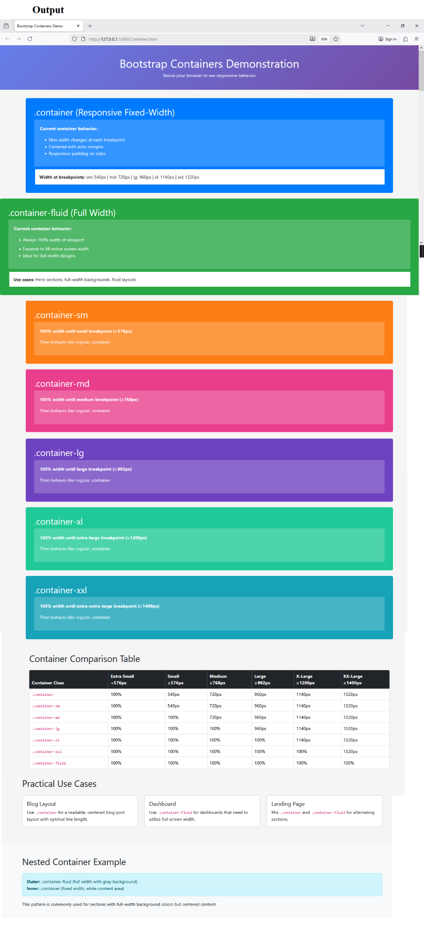
Experiment 6
Develop web pages with suitable HTML elements to demonstrate Bootstrap framework classes for Grid System
3. HTML Code (Grid Demonstration)
Save as grid.html.
<!doctype html>
<html lang="en">
<head>
<meta charset="utf-8">
<title>Bootstrap Grid System Demo</title>
<meta name="viewport" content="width=device-width, initial-scale=1">
<!-- Bootstrap 5 CSS CDN -->
<link href="https://cdn.jsdelivr.net/npm/bootstrap@5.3.3/dist/css/bootstrap.min.css" rel="stylesheet">
</head>
<body class="bg-light">
<div class="container my-4">
<h1 class="mb-4 text-center">Bootstrap Grid System Demo</h1>
<!-- Example 1: Equal columns -->
<h3>Equal width columns (col)</h3>
<div class="row mb-3">
<div class="col bg-primary text-white p-3">Column 1</div>
<div class="col bg-secondary text-white p-3">Column 2</div>
<div class="col bg-success text-white p-3">Column 3</div>
</div>
<!-- Example 2: Fixed column sizes -->
<h3>Fixed sizes (col-3, col-6, col-3)</h3>
<div class="row mb-3">
<div class="col-3 bg-info text-white p-3">col-3</div>
<div class="col-6 bg-warning text-dark p-3">col-6</div>
<div class="col-3 bg-danger text-white p-3">col-3</div>
</div>
<!-- Example 3: Responsive columns -->
<h3>Responsive columns (col-12 col-md-4)</h3>
<p class="text-muted">
On small screens these stack; on medium and above they appear in a row.
</p>
<div class="row mb-3">
<div class="col-12 col-md-4 bg-primary text-white p-3">col-12 col-md-4</div>
<div class="col-12 col-md-4 bg-success text-white p-3">col-12 col-md-4</div>
<div class="col-12 col-md-4 bg-secondary text-white p-3">col-12 col-md-4 </div>
</div>
<!-- Example 4: Nested grid -->
<h3>Nested grid</h3>
<div class="row">
<div class="col-8 bg-light border p-3">
Parent col-8
<div class="row mt-2">
<div class="col-6 bg-info text-white p-2">Nested col-6</div>
<div class="col-6 bg-warning text-dark p-2">Nested col-6</div>
</div>
</div>
<div class="col-4 bg-light border p-3">
Parent col-4
</div>
</div>
</div>
<!-- Bootstrap JS (optional) -->
<script src="https://cdn.jsdelivr.net/npm/bootstrap@5.3.3/dist/js/bootstrap.bundle.min.js"></script>
</body>
</html>

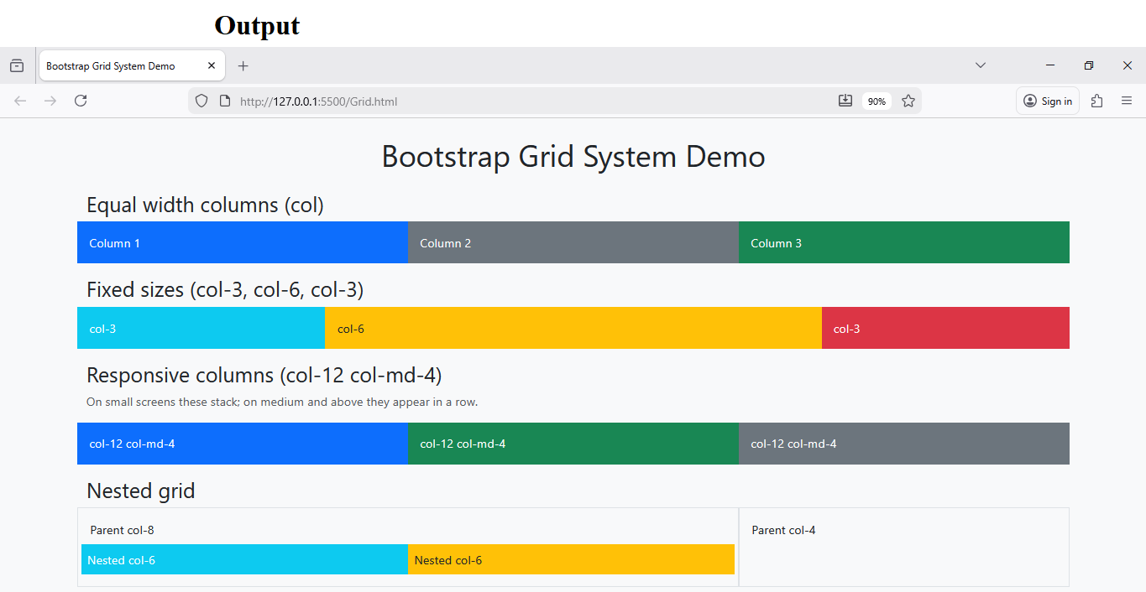

Experiment 7
Develop Web pages with suitable HTML elements to demonstrate Bootstrap framework classes for Images, Cards and Gutters
3. HTML Code (Images, Cards, Gutters)
Save as images-cards-gutters.html.
<!doctype html>
<html lang="en">
<head>
<meta charset="utf-8">
<title>Bootstrap Images, Cards and Gutters</title>
<meta name="viewport" content="width=device-width, initial-scale=1">
<link href="https://cdn.jsdelivr.net/npm/bootstrap@5.3.3/dist/css/bootstrap.min.css" rel="stylesheet">
</head>
<body class="bg-light">
<div class="container my-4">
<h1 class="mb-4 text-center">Images, Cards and Gutters</h1>
<!-- Images section -->
<h3>Responsive Images</h3>
<div class="row mb-4">
<div class="col-md-4">
<img src="https://picsum.photos/300/200" class="img-fluid rounded" alt="Random 1">
<p class="mt-2">img-fluid rounded</p>
</div>
<div class="col-md-4">
<img src="https://picsum.photos/200" class="img-fluid rounded-circle" alt="Random 2">
<p class="mt-2">img-fluid rounded-circle</p>
</div>
<div class="col-md-4">
<img src="https://picsum.photos/250/200" class="img-thumbnail" alt="Random 3">
<p class="mt-2">img-thumbnail</p>
</div>
</div>
<!-- Cards section -->
<h3>Cards with Images</h3>
<div class="row row-cols-1 row-cols-md-3 g-4 mb-4">
<div class="col">
<div class="card h-100">
<img src="https://picsum.photos/400/200?1" class="card-img-top" alt="Card 1">
<div class="card-body">
<h5 class="card-title">Card One</h5>
<p class="card-text">
This card demonstrates a basic card with image, title and text.
</p>
</div>
<div class="card-footer text-muted">
Updated 1 min ago
</div>
</div>
</div>
<div class="col">
<div class="card h-100 text-center">
<img src="https://picsum.photos/400/200?2" class="card-img-top" alt="Card 2">
<div class="card-body">
<h5 class="card-title">Card Two</h5>
<p class="card-text">
Cards can be used to display product information or blog posts.
</p>
<a href="#" class="btn btn-primary">Read more</a>
</div>
</div>
</div>
<div class="col">
<div class="card h-100 border-success">
<div class="card-header bg-success text-white">
Featured
</div>
<img src="https://picsum.photos/400/200?3" class="card-img-top" alt="Card 3">
<div class="card-body">
<h5 class="card-title">Card Three</h5>
<p class="card-text">
This card has a colored border and header to highlight content.
</p>
</div>
</div>
</div>
</div>
<!-- Gutters section -->
<h3>Gutters (Spacing between columns)</h3>
<h5 class="mt-3">Row with g-0 (no gutters)</h5>
<div class="row g-0 mb-3 text-white">
<div class="col-md-6 p-3 bg-primary">Column A (g-0)</div>
<div class="col-md-6 p-3 bg-danger">Column B (g-0)</div>
</div>
<h5>Row with g-4 (default gutters)</h5>
<div class="row g-4 mb-3 text-white">
<div class="col-md-4 p-3 bg-success">Column 1 (g-4)</div>
<div class="col-md-4 p-3 bg-secondary">Column 2 (g-4)</div>
<div class="col-md-4 p-3 bg-warning text-dark">Column 3 (g-4)</div>
</div>
<h5>Separate horizontal and vertical gutters (gx-5 gy-2)</h5>
<div class="row gx-5 gy-2 mb-3 text-white">
<div class="col-md-4 p-3 bg-dark">gx-5 gy-2</div>
<div class="col-md-4 p-3 bg-primary">gx-5 gy-2</div>
<div class="col-md-4 p-3 bg-danger">gx-5 gy-2</div>
</div>
</div>
<script src="https://cdn.jsdelivr.net/npm/bootstrap@5.3.3/dist/js/bootstrap.bundle.min.js"></script>
</body>
</html>
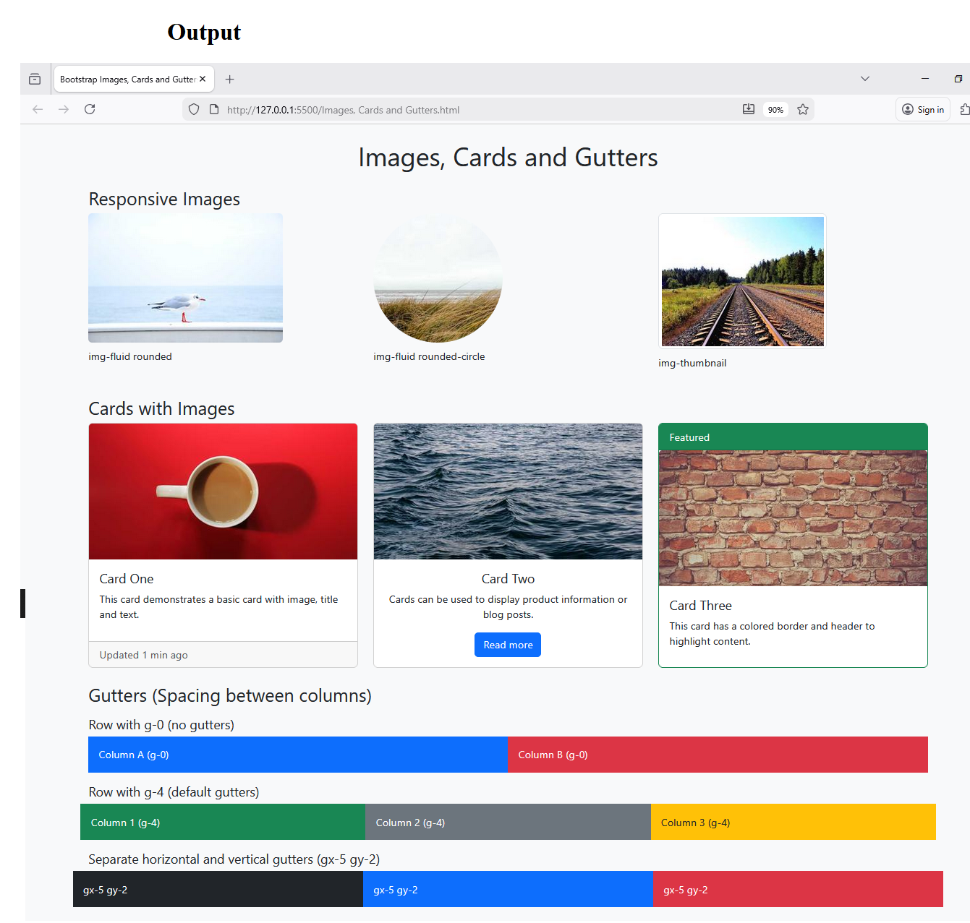

Experiment 8
Develop a Web Page with suitable HTML elements to demonstrate Bootstrap framework classes for Nav and Footers
3. HTML Code (Nav & Footer)
Save as nav-footer.html.
<!doctype html>
<html lang="en">
<head>
<meta charset="utf-8">
<title>Bootstrap Nav and Footer</title>
<meta name="viewport" content="width=device-width, initial-scale=1">
<link href="https://cdn.jsdelivr.net/npm/bootstrap@5.3.3/dist/css/bootstrap.min.css" rel="stylesheet">
</head>
<body>
<!-- Navbar -->
<nav class="navbar navbar-expand-lg navbar-dark bg-dark">
<div class="container-fluid">
<a class="navbar-brand" href="#">MySite</a>
<button class="navbar-toggler" type="button" data-bs-toggle="collapse"
data-bs-target="#navbarSupportedContent" aria-controls="navbarSupportedContent"
aria-expanded="false" aria-label="Toggle navigation">
<span class="navbar-toggler-icon"></span>
</button>
<div class="collapse navbar-collapse" id="navbarSupportedContent">
<!-- Left nav items -->
<ul class="navbar-nav me-auto mb-2 mb-lg-0">
<li class="nav-item">
<a class="nav-link active" aria-current="page" href="#">Home</a>
</li>
<li class="nav-item">
<a class="nav-link" href="#features">Features</a>
</li>
<li class="nav-item">
<a class="nav-link" href="#contact">Contact</a>
</li>
<!-- Dropdown -->
<li class="nav-item dropdown">
<a class="nav-link dropdown-toggle" href="#" id="navbarDropdown" role="button"
data-bs-toggle="dropdown" aria-expanded="false">
More
</a>
<ul class="dropdown-menu" aria-labelledby="navbarDropdown">
<li><a class="dropdown-item" href="#">Action</a></li>
<li><a class="dropdown-item" href="#">Another action</a></li>
<li><hr class="dropdown-divider"></li>
<li><a class="dropdown-item" href="#">Something else here</a></li>
</ul>
</li>
</ul>
<!-- Right side search form -->
<form class="d-flex" role="search">
<input class="form-control me-2" type="search" placeholder="Search" aria-label="Search">
<button class="btn btn-outline-success" type="submit">Search</button>
</form>
</div>
</div>
</nav>
<!-- Main content -->
<main class="container my-4">
<section id="features" class="mb-5">
<h2>Features</h2>
<p>
This section demonstrates how the navbar links scroll to different parts of the page.
</p>
</section>
<section id="contact" class="mb-5">
<h2>Contact</h2>
<p>
You can add contact details or a form here.
</p>
</section>
</main>
<!-- Footer -->
<footer class="bg-dark text-white mt-auto py-4">
<div class="container">
<div class="row">
<div class="col-md-4 mb-3">
<h5>About</h5>
<p>
Simple footer built using Bootstrap grid and utility classes.
</p>
</div>
<div class="col-md-4 mb-3">
<h5>Quick Links</h5>
<ul class="nav flex-column">
<li class="nav-item"><a href="#" class="nav-link p-0 text-white-50">Home</a></li>
<li class="nav-item"><a href="#features" class="nav-link p-0 text-white-50">Features</a></li>
<li class="nav-item"><a href="#contact" class="nav-link p-0 text-white-50">Contact</a></li>
</ul>
</div>
<div class="col-md-4 mb-3">
<h5>Follow Us</h5>
<ul class="list-unstyled">
<li><a href="#" class="text-white-50">Twitter</a></li>
<li><a href="#" class="text-white-50">LinkedIn</a></li>
<li><a href="#" class="text-white-50">GitHub</a></li>
</ul>
</div>
</div>
<div class="text-center text-white-50">
&copy; 2026 MySite. All rights reserved.
</div>
</div>
</footer>
<script src="https://cdn.jsdelivr.net/npm/bootstrap@5.3.3/dist/js/bootstrap.bundle.min.js"></script>
</body>
</html>

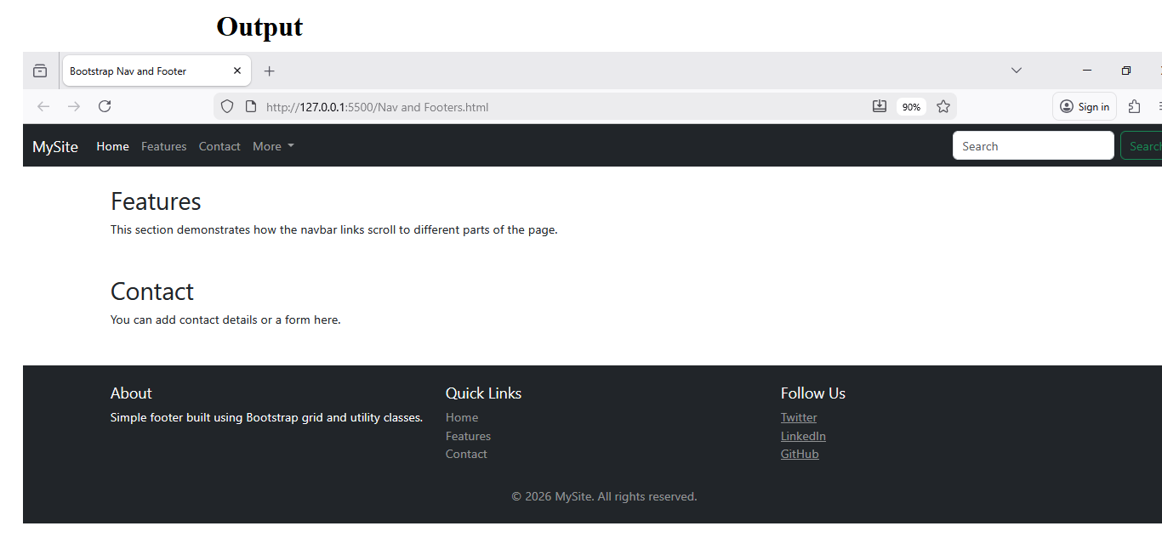
Experiment 9
Create a responsive web application using Bootstrap and Test it on Postman.
(Here we model a very simple “API‑driven” front‑end that calls a public API, so you can demonstrate testing endpoints with Postman.)

3. HTML + JS Code (Simple API‑driven App)
This example calls the public JSONPlaceholder API (https://jsonplaceholder.typicode.com/posts) to fetch posts.
Save as api-app.html.

<!doctype html>
<html lang="en">
<head>
<meta charset="utf-8">
<title>Bootstrap API Demo App</title>
<meta name="viewport" content="width=device-width, initial-scale=1">
<link href="https://cdn.jsdelivr.net/npm/bootstrap@5.3.3/dist/css/bootstrap.min.css" rel="stylesheet">
</head>
<body class="bg-light">
<nav class="navbar navbar-expand-lg navbar-dark bg-primary">
<div class="container-fluid">
<a class="navbar-brand" href="#">API Demo</a>
</div>
</nav>
<div class="container my-4">
<h1 class="mb-3 text-center">Posts Viewer</h1>
<p class="text-muted text-center">
Click the button to load posts from a public REST API.
</p>
<div class="text-center mb-3">
<button id="loadPostsBtn" class="btn btn-success">Load Posts</button>
</div>
<!-- Loading indicator -->
<div id="loading" class="text-center text-secondary mb-3" style="display:none;">
Loading...
</div>

<!-- Error message -->
<div id="error" class="alert alert-danger d-none" role="alert">
Failed to load posts. Please try again.
</div>
<!-- Posts container -->
<div id="postsContainer" class="row row-cols-1 row-cols-md-2 g-4">
<!-- Cards will be inserted here dynamically -->
</div>
</div>
<script>
const loadBtn = document.getElementById('loadPostsBtn');
const postsContainer = document.getElementById('postsContainer');
const loading = document.getElementById('loading');
const errorDiv = document.getElementById('error');
loadBtn.addEventListener('click', () => {
loading.style.display = 'block';
errorDiv.classList.add('d-none');
postsContainer.innerHTML = '';
fetch('https://jsonplaceholder.typicode.com/posts?_limit=6')
.then(response => response.json())
.then(data => {
loading.style.display = 'none';
data.forEach(post => {
const col = document.createElement('div');
col.className = 'col';
col.innerHTML = `
<div class="card h-100">
<div class="card-body">
<h5 class="card-title">${post.title}</h5>
<p class="card-text">${post.body}</p>
</div>
<div class="card-footer text-muted">
Post ID: ${post.id}
</div>
</div>
`;
postsContainer.appendChild(col);
});
})
.catch(err => {
console.error(err);
loading.style.display = 'none';
errorDiv.classList.remove('d-none');
});
});
</script>
<script src="https://cdn.jsdelivr.net/npm/bootstrap@5.3.3/dist/js/bootstrap.bundle.min.js"></script>
</body>
</html>
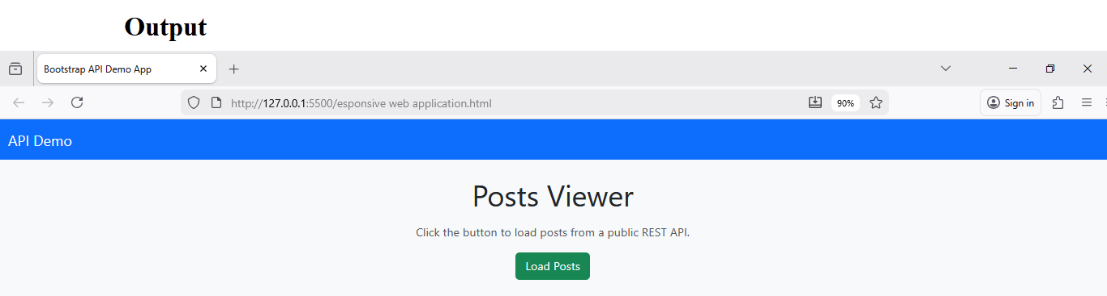After clicking on Load Post 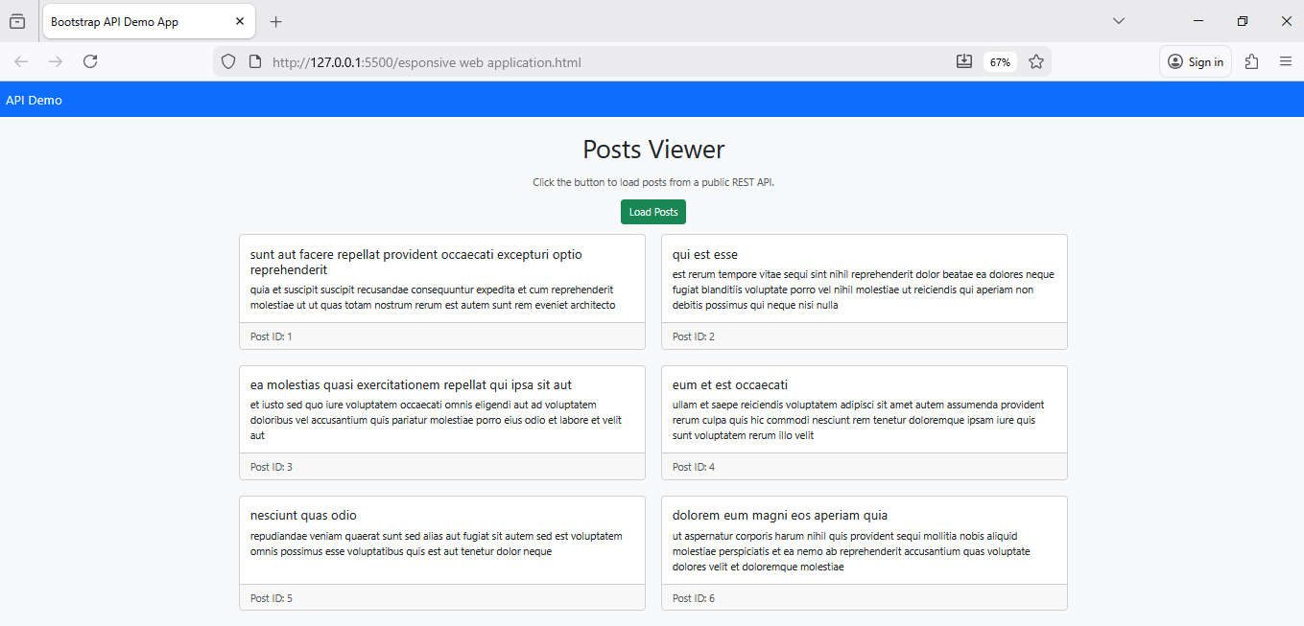Button

Experiment 10
Develop a web application using Vercel
1. Aim
To develop a Bootstrap‑based web application and deploy it using Vercel.
2. Theory
- Vercel is a platform for deploying static and serverless web applications with automatic builds from Git repositories.^{[6][7]}
- It supports direct GitHub/GitLab/Bitbucket integration and provides a unique URL for every deployment.
- Static Bootstrap sites (HTML/CSS/JS only) can be deployed without special configuration.
3. Minimal App Code for Deployment
You can deploy any of the previous experiments; here is a simple single‑file home page.
Save as index.html in a folder (e.g., bootstrap-vercel-app/).
<!doctype html>
<html lang="en">
<head>
<meta charset="utf-8">
<title>My Bootstrap App on Vercel</title>
<meta name="viewport" content="width=device-width, initial-scale=1">
<link href="https://cdn.jsdelivr.net/npm/bootstrap@5.3.3/dist/css/bootstrap.min.css" rel="stylesheet">
</head>
<body class="bg-light">
<nav class="navbar navbar-expand-lg navbar-dark bg-dark">
<div class="container-fluid">
<a class="navbar-brand" href="#">Vercel Demo</a>
</div>
</nav>
<div class="container my-4">
<h1 class="mb-3">Welcome to my deployed Bootstrap app</h1>
<p class="lead">
This page is deployed on Vercel and built using Bootstrap 5.
</p>
<div class="row row-cols-1 row-cols-md-3 g-4">
<div class="col">
<div class="card h-100">
<div class="card-body">
<h5 class="card-title">Grid</h5>
<p class="card-text">Responsive layouts with 12-column system.</p>
</div>
</div>
</div>
<div class="col">
<div class="card h-100">
<div class="card-body">
<h5 class="card-title">Components</h5>
<p class="card-text">Navbars, cards, images, buttons and more.</p>
</div>
</div>
</div>
<div class="col">
<div class="card h-100">
<div class="card-body">
<h5 class="card-title">Deployment</h5>
<p class="card-text">Continuous deployment via Vercel + Git.</p>
</div>
</div>
</div>
</div>
</div>
<footer class="bg-dark text-white text-center py-3 mt-4">
&copy; 2026 My Bootstrap Vercel App
</footer>
<script src="https://cdn.jsdelivr.net/npm/bootstrap@5.3.3/dist/js/bootstrap.bundle.min.js">
</script>
</body>
</html>

